Refusal Skills Comic Strip Assignment
Name: Period:
Using your assigned scenario, create a ‘comic strip’ style project to SHOW the refusal skills in practice. It should include the information from the scenario including the location, characters, and the conversation. Here is a sample of a comic strip, although it doesn’t directly relate to the content. This is to be used as an EXAMPLE only. It shows how you can create a scene without using words in EVERY panel, you can represent individuals in different ways (animals as people), you can make the storyline somewhat confusing (as long as it’s still follow-able). The key is that you show someone practicing one or more refusal skills.
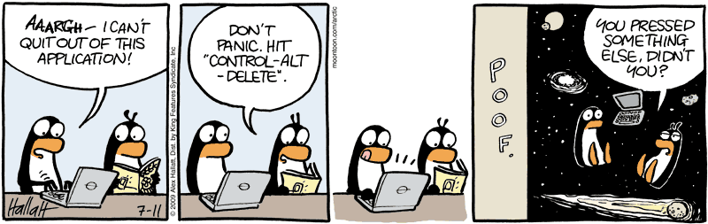
Comic Strip Requirements:
- Contains at least 5 panels
- Uses one (or more) of the refusal skills
- Uses the characters in your scenario

Refusal Skills Comic Strip Assignment
Name: Period:
Using your assigned scenario, create a ‘comic strip’ style project to SHOW the refusal skills in practice. It should include the information from the scenario including the location, characters, and the conversation. Here is a sample of a comic strip, although it doesn’t directly relate to the content. This is to be used as an EXAMPLE only. It shows how you can create a scene without using words in EVERY panel, you can represent individuals in different ways (animals as people), you can make the storyline somewhat confusing (as long as it’s still follow-able). The key is that you show someone practicing one or more refusal skills.
Comic Strip Requirements:
- Contains at least 5 panels
- Uses one (or more) of the refusal skills
- Uses the characters in your scenario

